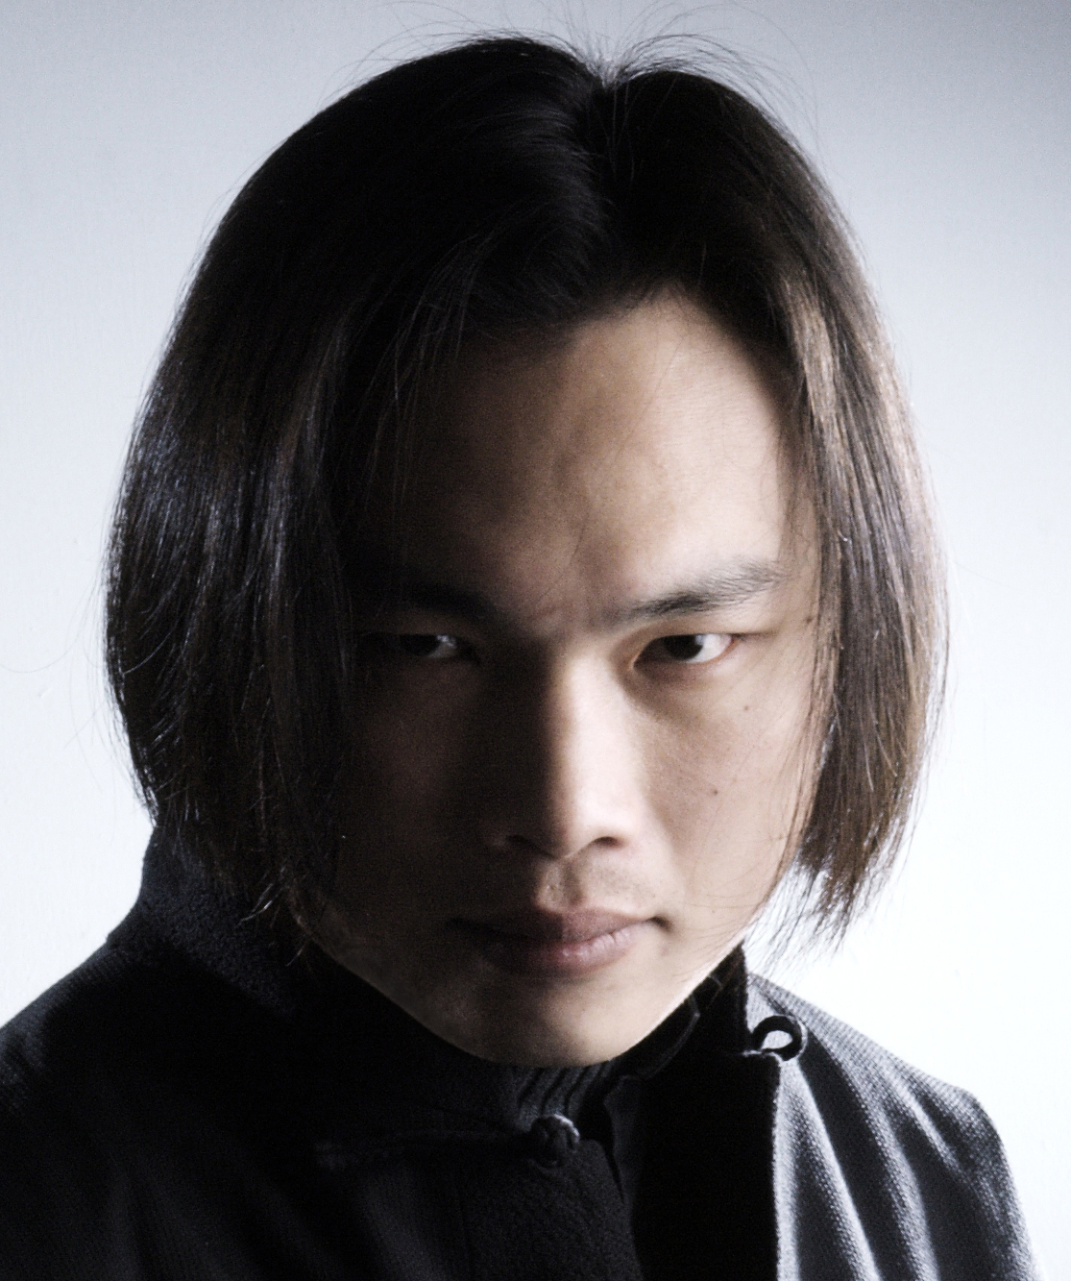
施宣宇Samuel Hsuan-Yu. Shih
Tel: +886-2-2636-3999
Gsm: +886-919-999-074
25242 No.39, Haijing 5th St., Sanzhi Dist., New Taipei City, Taiwan (R.O.C)
unit.office@gmail.com
www.UNIT-9.com

Biography

Enrolled in Santa Anna Art Academy, Ceramic Studio, California, U.S.A
Certificate Awarded [Taiwanese Craft Master] by National Taiwan Craft Research and Development Institute
Art Director of UNIT-9 Ceramics & Visual Arts Office
Teacher of New Taipei City Yingge Ceramics Museum, Taiwan
Judge of Competition of New Taipei City Yingge Ceramics Museum, Taiwan
Print media Spokesman of Volkswagen in Taiwan in 2009

Sponsors

2011 Taiwan Fine Art Grant of National Taiwan Craft Research and Development Institute
2006 Japan Fine Art Grant of Tajimi City Government of Cultural Affairs
2004 U.K Fine Art Grant of Gasworks and Triangle Arts Trust
2004 Taiwan Fine Art Grant of Taipei City Government of Cultural Affairs
2002 Taiwan Fine Art Grant of National Culture and Art Foundation
2001 Taiwan Fine Art Grant of Council for cultural Affairs
2000 Taiwan Fine Art Grant of Taipei City Government of Cultural Affairs
1999 Taiwan Fine Art Grant of National Culture and Art Foundation

International Artist in Residence

2011 Spain Madrid City International Artist in residence
2007 Japan MINONOKUNI International Artist in residence
2006 Pakistan VASL International Artist in residence
2006 Pakistan Karachi Rangoon Walla Community Centre Artist in residence
2001 U.S.A. Anderson Ranch Arts Center Artist in residence
2001 U.S.A. New York city Artist in residence

Prize and Collection

2011 [ Prize of the Assemblea Legislatva of Reggione Emilia-Romagna ]
57th Italy Premio Faenza International Competition of Contemporary Ceramic Art /
International Museum of Ceramics in Faenza, Italy
2010 [ Gold ] The 3rd Taiwan Gold Teapot Prize /
New Taipei City Yingge Ceramics Museum, Taiwan
2003 [ Gold ] The 3rd Taipei Ceramics Awards /
New Taipei City Yingge Ceramics Museum, Taiwan
2002 [ Gold ] The 16th Nan-Yin Annual Art Competition /
Tainan County Culture Center, Taiwan
2009 [ Prize of the Chambers of Deputies ]
56th Italy Premio Faenza International Competition of Contemporary Ceramic Art /
International Museum of Ceramics in Faenza, Italy
2000 [ UK Special ] Australia Gold Coast Arts Center International Ceramic Fair
Golden Beach Art Center, Australia
2000 [ Silver ] International Biennial Exhibition of Ceramic Art /
National Museum of History, Taiwan
2000 [ Silver ] The 14th Nan-Yin Annual Art Competition /
Tainan County Culture Center, Taiwan
1998 [ Silver ] Golden Oriole Ceramic Prize /
United News Culture & Education Foundation, Taiwan
1992 [ Silver ] The 1st Golden Ceramic Prize /
Chiu Hocheng Cultural & Educational Foundation, Taiwan

2007 [ Collection ] New Taipei City Yingge Ceramics Museum, Taiwan / Sammi
2007 [ Collection ] Tajimi City, Gifu Prefecture, Japan / Memory in the wind Ⅳ
2007 [ Collection ] Museum of Modern Ceramic Art Gifu, Japan / Memory in the wind Ⅶ
2006 [ Collection ] National Museum of History, Taiwan / Pictures of Two Cities
2006 [ Collection ] City District Government Karachi, Pakistan / Tears of Sitar
2003 [ Collection ] New Taipei City Yingge Ceramics Museum, Taiwan /
The Axis of the Metagalaxy - Sitar
2002 [ Collection ] Tainan City Government Department of Cultural Affairs /
Rules of Shuttle
2000 [ Collection ] National Museum of History, Taiwan / Consensual Hallucination
1998 [ Collection ] United News Culture and Education Foundation, Taiwan / Shuttle
1992 [ Collection ] Chiu Ho-Chen Culture and Education Foundation, Taiwan / Narrow Door

Books
「Close the World / Open the next」 Published by New Taipei City Yingge Ceramics Museum, Taiwan

Solo Exhibitions

2011 [ XI ] Italy Museum of Contemporary Art, Roma
2011 [ Xinhai ] Italy Faenza City Goverment Art Gallery, Faenza
2011 [ JOY² ] Spain Madrid City Art Center, Madrid
2010 [ Cheng ] Taiwan Elsa Art Gallery, Taipei
2010 [ Art Taipei 2010-Vermilion Bird ] Taiwan Taipei World Trade Center
2007 [ Memory in the Wind-Poetry 14 ] Japan Museum of Modem Ceramic Art. Gifu
2004 [ Close the World / Open the next ] Taiwan New Taipei City Yingge Ceramics Museum
1999 [ The Wings in the Wind ] Taiwan Chinchu Caves Art Center
1998 [ The Axis of the Metagalaxy ] Taiwan Taipei Caves Art Center
1994 [ Be in a State of Equilibrium ] Taiwan Taipei Caves Art Center

Public Arts

2010 [ Invited ] International Invited case Hong Kong International Commerce Center
2009 [ First prize ] Public selection New Taipei City Department of CulturalAffairs,San-Ying Spatial Art District
2009 [ Second place ] Invited case Department of Rapid Transit Systems,
Taipei City Government No. CK240B MRT Daqiao Elementary School Station
2005 [ Invited ] Commissioned case Fang-yuan Culture and Arts Foundation,
Fang-yuan museum

International Art Auction

2011 [ Modern and Contemporary Ceramic Art - Spring Auction ]
China Beijing China Guardian Auctions Co., Ltd.
2010 [ Modern and Contemporary Ceramic Art - Autumn Auction ]
China Beijing China Guardian Auctions Co., Ltd.
2010 [ Modern and Contemporary Ceramic Art - Spring Auction ]
China Beijing China Guardian Auctions Co., Ltd.
2009 [ Modern and Contemporary Ceramic Art - Autumn Auction ]
China Beijing China Guardian Auctions Co., Ltd.
2009 [ Modern and Contemporary Ceramic Art - Spring Auction ]
China Beijing China Guardian Auctions Co., Ltd.
2009 [ Contemporary Art / Oil Painting & Sculpture ]
China ShangHai HOZANE international auction house
2008 [ Modern and Contemporary Ceramic Art - Autumn Auction ]
China Beijing China Guardian Auctions Co., Ltd.
2008 [ Modern and Contemporary Ceramic Art - Spring Auction ]
China Beijing China Guardian Auctions Co., Ltd.

Group Exhibition

2011 [ Taipei World Design Expo ]
International Design Exhibition / TAIWAN /
Ministry of Economic Affairs, R.O.C
2011 [ Go on the Stage ]
Joint Exhibition for Selected Taiwanese Submissions / TAIWAN /
National Taiwan Craft Research and Development Institute
- [ 57° Premio Faenza ]
International Art Joint Exhibition / Italy /
International Museum of Ceramics in Faenza
- [ Tea - Taiwan, Tea set, Tea landscape ]
Ceramic Invitational Exhibition / USA /
Culture Center of Taipei Economic and Cultural Office in Los Angeles
2011 [ Tea - Taiwan, Tea set, Tea landscape ]
Ceramic Invitational Exhibition / USA /
Culture Center of Taipei Economic and Cultural Office in Houston
2010 [ Taiwan Gold Teapot Prize ]
Ceramic Invitational Exhibition /Taiwan / New Taipei City Yingge Ceramics Museum
- [ Nang-Ying Biennale Classic Nang-Ying Exhibition ]
An Invitational Art Exhibition / Taiwan /Tainan County Government
2010 [ 2010 Taiwan Ceramic Exhibition ]
An Invitational Ceramic Exhibition / Taiwan / Taichung County Cultural Center
- [ A Wedding Feast ]
An Invitational Ceramic Exhibition / Taiwan / New Taipei City Yingge Ceramics Museum
2010 [ Happiness Exhibition of Life Aesthetics ]
An Invitational Ceramic Exhibition / Taiwan / National Hsinchu Living Art Center
- [ Exploring the Aesthetics of life ]
An Invitational Ceramics Exhibition / Taiwan / New Taipei City Yingge Ceramics Museum
2009 [ Plays of Texture- New Generation Ceramics in Taiwan ]
An Invitational Ceramic Exhibition / Hong Kong / Hong Kong Arts Centre
2009 [ 56°PREMIO FAENZA ]
International Art Joint Exhibition / Italy / International Museum of Ceramics in Faenza
2009 [ Art Future Exhibition ]
International Art Exhibition / Japan / The National Art Center, Tokyo
2008 [ Ceramics of the world ]
A Biennial of Ceramics / Belgium / Andenne City Hall
2008 [ Space‧Image‧Game ]
Ceramic Joint Exhibition / Taiwan / Taipei County Yingge Ceramics Museum
2008 [ Staring at the Area to Record the World while it is Changing Dissipating and Reconstructing ] CERCO 08 / Spain / Centro de Artesania de Aragon
2008 [ Utensil and Innovative Artworks - Contemporary Ceramics in Taiwan ]
Beijing Olympic Cultural Festival Invitational Exhibition / China / National Art Museum of China
- [ A Wedding Feast ]
Taiwanese Elegance in Banquets an Exhibition of Tableware / Taiwan /
New Taipei City Yingge Ceramics Museum
2007 [ Asian Ceramic Delta Project ]
International Art Joint Exhibition / Japan / Museum of Modern Ceramic Art, Gifu
2007 [ Space ON ]
International Ceramic Joint Exhibition / Japan / Gifu Museum of Fine Arts
2007 [ Asian Ceramic Delta Project ]
International Art Joint Exhibition / Taiwan / New Taipei City Yingge Ceramics Museum
2006 [ Asian Ceramic Delta Project ]
International Art Joint Exhibition / Korea / World Ceramic Exposition Foundation
2006 [ ASNA Clay Triennial ]
International Ceramic Joint Exhibition / Pakistan / VM Art Gallery
2006 [ Modern Ceramics ]
Ceramic Joint Exhibition / Taiwan / National Museum of History
2006 [ New Tableware Generation ]
Ceramic Joint Exhibition / Taiwan / New Taipei City Yingge Ceramics Museum
2006 [ FIVE 6 ]
International Art Joint Exhibition / Pakistan / VM Art Gallery
2006 [ The Art ]
International Art Joint Exhibition / Pakistan / VASL International Artists` Collective
2003 [ Blessed by Heaven ]
Creative Exhibition / Taiwan / Taipei Cloud Art Center
2003 [ Equilibrium ]
Creative Exhibition / Taiwan / Kaohsiung Dear Gallery
2003 [ The Monsoon ]
Ceramic Joint Exhibition / Taiwan / Place 2 Studio
2002 [ Modern Ceramics ]
Ceramic Joint Exhibition / Taiwan / Chiang Kai-Shek Memorial Hall Gallery
2002 [ Confused Islands ]
Invited Exhibition / Taiwan / The pier-2 Art District Kaohsiung
2001 [ Plum Blossom & Bamboo ]
Invited Ceramic Exhibition / Taiwan / National Tsing Hua University
2000 [ Asian Exhibition of Art and Crafts, 2000 ]
Japan / Fukuoka Fine Art Museum
2000 [ Asian Exhibition of Art and Crafts ]
Taiwan Special Exhibition / Taiwan / Taipei Fine Art Museum
2000 [ Two Generation Love ]
Creative Exhibition / Taiwan / Renown Exhibit Art Center
2000 [ Misssssss-speed ]
Video Art Installation Exhibition / Taiwan / Huashan Arts District
2000 [ The Ephemeral ]
Stationed Installation Exhibition / Taiwan / Bamboo Frame Studio
2000 [ Purple Gold Garden ]
Creative Exhibition / Taiwan / Taipei Caves Art Center
1999 [ Asian Exhibition of Arts and Crafts ]
Japan / Fukuoka Fine Art Museum,
1998 [ Taiwan Ceramics Collection ]
USA / R.S.C. Art Center, CA
1998 [ Modern Ceramics ]
Invited Exhibition / Taiwan / National Museum of History
- [ The Art ]
Ceramic Joint Exhibition / Taiwan / Taipei Caves Art Center

